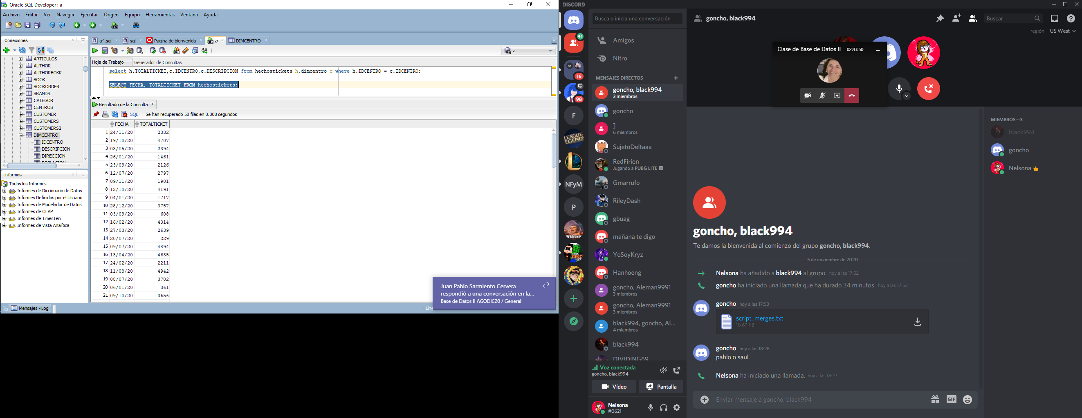select h.TOTALTICKET,c.IDCENTRO,c.DESCRIPCION from hechostickets h,dimcentro c where h.IDCENTRO = c.IDCENTRO;

SELECT FECHA, TOTALTICKET FROM hechostickets;